MAMP Installation Guide

1. Go to [**http://www.mamp.info/en/downloads/**](http://www.mamp.info/en/downloads/) and download the latest by clicking on the download button.
2. It is a standard mac installation (choose the free version unless you wish to purchase the MAMP Pro)
3. Now lunch MAMP (gray icon for the free version, blue icon for the paid or pro version)

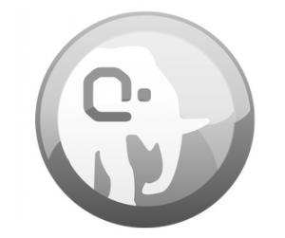

1. You should see a new window click start server for MAMP to start working and serving files to your local browser.

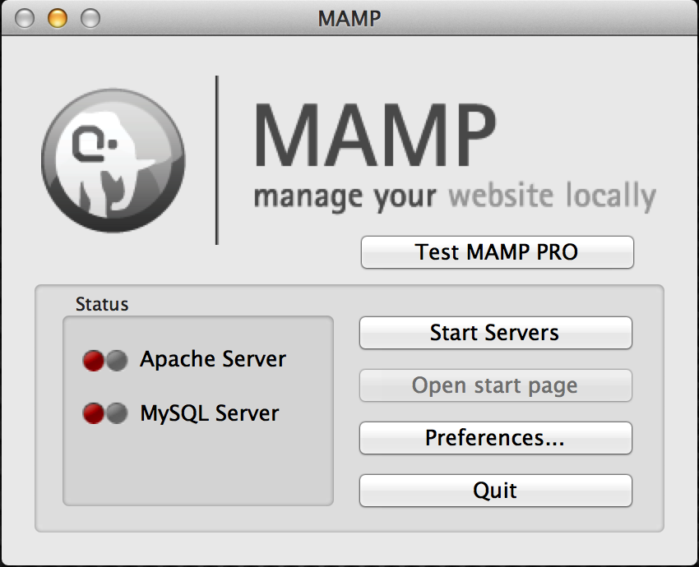

1. In your local browser type [**http://localhost:8888/**](http://localhost:8888/), this is your default MAMP Server page.
2. To Add files navigate to your Application -> MAMP -> htdocs and add any website related files here. **/Applications/MAMP/htdocs**
3. Now lets create php file to test the server. Create a php files with a print statement, and name it test.php and put that file in the htdocs folder. Then open a browser and type [**http://localhost:8888/test.php**](http://localhost:8888/test.php)
4. To access your MySQL database type **http://localhost:8888/MAMP/** and there should be a tab called **phpMyAdmin**.

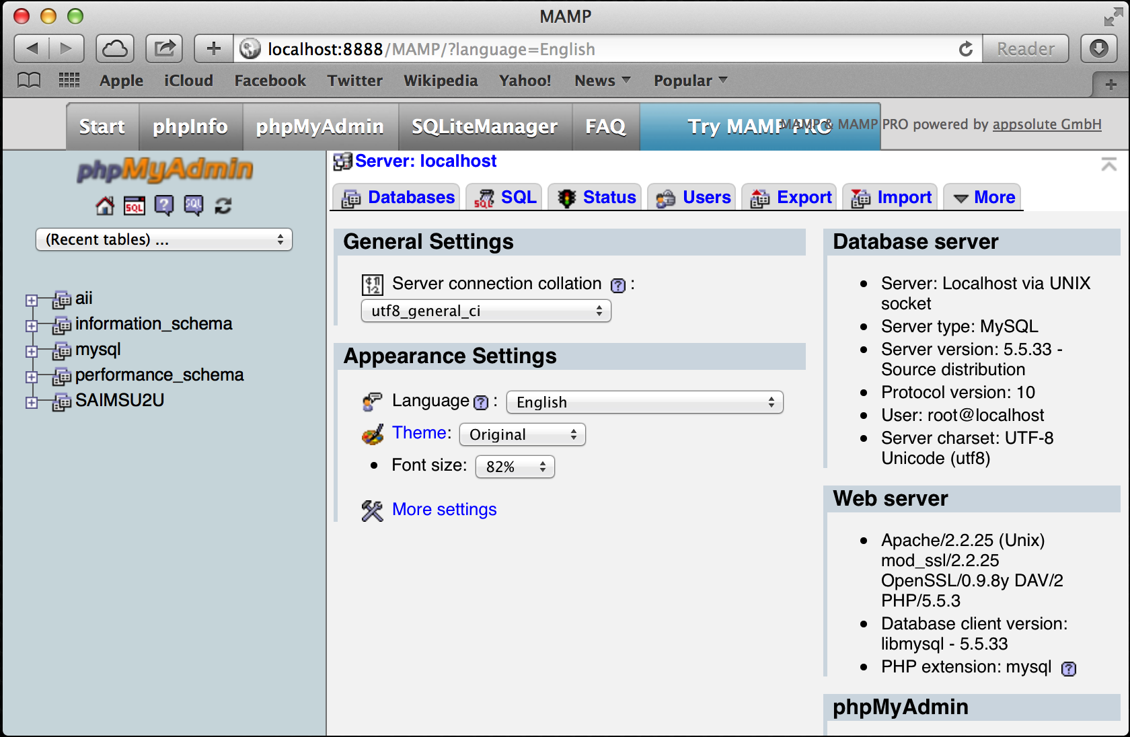

1. You should be able to view the php page now, and you’re done.